

**[CL-2018] OPERATING SYSTEM**

**PROJECT PROPOSAL**

**“BASIC OPERATING SYSTEM WITH PROCESS AND MEMORY MANAGEMENT”**

**Group Members:**

|  |  |
| --- | --- |
| **Name** | **Roll No** |
| Shayan Hashmi | 22k-4865 |
| Syed Ammar Zulfiqar | 22k-4845 |
| Murtaza Hussain | 22k-4863 |

**SECTION: A**

**Instructor: Engr. Muhammad Afnan Malik**

**DEPARTMENT OF ELECTRICAL ENGINEERING**

**NATIONAL UNIVERSITY OF COMPUTER AND EMERGING SCIENCES (NUCES) KARACHI CAMPUS**

1. **INTRODUCTION:**

* **Motivation:** The operating system (OS), which controls the allocation of memory, processes, and hardware resources, are the fundamentals of contemporary computing. Students can understand fundamental ideas such as memory management, file system and process programming, creating a simple operating system. The project provides resource management and system programming.
* **Problem Statement with Targeted SDGs:** Due to their complexity, modern operating systems can be a challenge for novices to understand. The project aims to create an unavailable operating system that integrates the main operating system ideas, including memory allocation, process scheduling, file system operations, and command line interface interactions.

By improving student’s understanding and proficiency in system-level programming, the project supports Sustainable Development Goals (SDGs) 4 (Quality Education) and SDG9 (Industry, Innovation and Infrastructure).

* **Proposed Solution With Block Diagram:** A kernel, agendator, memory management, and an interface file system make up the suggested system. The system architecture is shown on the block diagram, which is as follows.

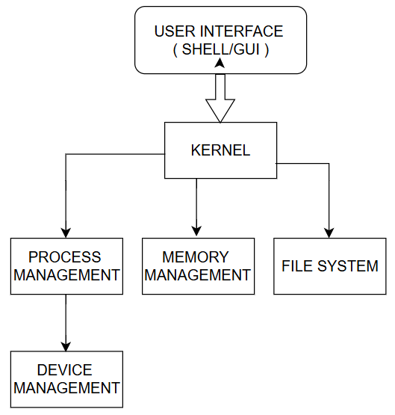

1. **LITERATURE REVIEW:**

The efficiency of operating systems relies heavily on the management of processes and memory. This literature review will highlight the research done in this regard that has significantly affected modern operating systems. [1]**Revisiting Hybrid Memory Management in Modern Operating Systems:** According to Liu et al. (2017) the Memos system is designed to manage hybrid DRAM-NVM architectures, which was framed in this publication. The Memos system dynamically improves the position of data within the memory structure using online memory patterns and available resources. Experimental results demonstrated that Memos enhances system throughput by 19.1% and quality of service by 23.6%. It also achieved a considerable improvement in the maximum performance level of NVM memory by E-single Ch-Correcting Energy DISSIPATOR of Memory NVM, decreasing the speed of access memory energy expenditure. Consequently, lifetime NVM is benefited. [2]**Controlling Page-Tables and TLBs in NUMA Systems:** Gao et al. (2024) introduced numaPTE, which is a new page-table management tool that was built for non-uniform memory access (NUMA) systems. numaPTE supports on-demand partial page-table replication across NUMA nodes, which enables address translation that is local to the nodes and therefore reduces TLB shootdowns. Implementations in Linux on x86_64 platforms have already shown that numaPTE leads to some astonishing results like a 12 percent improvement to runtime. [3]**Boosting OS Memory Management Performance:** Omar and colleagues (2021) did a thorough review that looked at operating system functions and how memory management units (MMUs) play a part in process management. The study stressed how crucial it is to have effective memory allocation and deallocation, ways to sync, and communication between processes. The researchers pointed out several methods and approaches to make memory management perform better helping to create stronger and more productive operating systems. [4]**Memory Management Approaches for Internet of Things (IoT) Systems:** Comeagă and Marin (2023) looked into memory management issues in IoT devices, which often have to deal with limited memory and processing power. Their research dug deep into memory allocation, scene execution, memory reduction, and how well IoT operating systems can scale up. They found that handling memory well is key to making the best use of resources keeping devices responsive, and helping them adapt to the growing world of IoT.[5] **Advanced Memory Management Techniques Boost Operating System Performance:** Jalaman and Teleron (2024) looked into cutting-edge memory management methods and how they affect operating system performance. Their research took a deep dive into paging, segmentation, and virtual memory, along with ideas like shadow page tables, copy-on-write, and memory ballooning. The authors ran lots of tests and benchmarks showing that these advanced techniques make systems run better and use resources more effectively.

Together, these studies highlight how process and memory management in operating systems keep changing. New ideas like hybrid memory systems and special strategies for IoT devices help to create operating systems that are more efficient, can grow, and respond.

1. **PROJECT MILESTONES AND DELIVERABLES:**

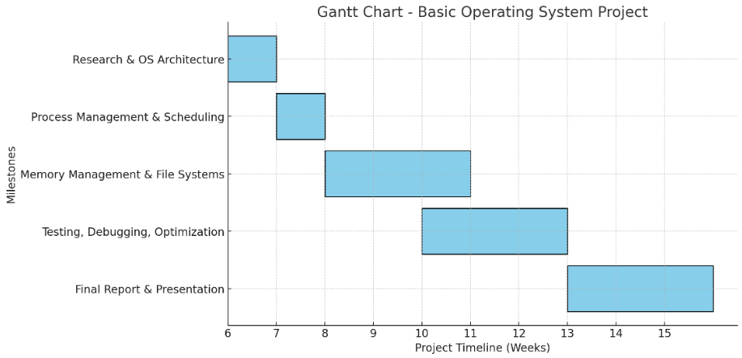

1. **WORK DIVISION:**

|  |  |  |
| --- | --- | --- |
| **S.NO.** | **TEAM MEMBER** | **CONTRIBUTION** |
|  | Murtaza Hussain | Process management and scheduling implementation. |
|  | Shayan Hashmi | Memory management and paging techniques. |
|  | Syed Ammar | File system development and CLI integration. |

1. **COSTING:**

|  |  |  |
| --- | --- | --- |
| **S.NO.** | **COMPONENTS** | **ESTIMATED COST ( PKR )** |
|  | Development Board (Raspberry Pi/VM) | Rs. 10,000 |
|  | Storage (SD Card/Virtual Disk) | Rs. 5,500 |
|  | Power Supply and Accessories | Rs. 3,000 |
|  | Software Tools | Free/Open Source |
|  | Total Cost | Rs. 18,500 |

1. **REFERENCES:**

[1] L. Liu, M. Xie, and H. Yang, “Memos: Revisiting Hybrid Memory Management in Modern Operating System.”

[2] B. Gao, Q. Kang, H.-W. Tee, K. T. N. Chu, A. Sanaee, and D. Jevdjic, “numaPTE: Managing Page-Tables and TLBs on NUMA Systems,” Jan. 2024, [Online]. Available: http://arxiv.org/abs/2401.15558

[3] N. Ramadhan Omar *et al.*, “Enhancing OS Memory Management Performance: A Review,” 2021. [Online]. Available: https://www.researchgate.net/publication/351969783

[4] “2311.10458v1”.

[5] J. R. C. Jalaman and J. I. Teleron, “Optimizing Operating System Performance through Advanced Memory Management Techniques: A Comprehensive Study and Implementation,” *Engineering and Technology Journal*, vol. 09, no. 05, May 2024, doi: 10.47191/etj/v9i05.33.